After careful analysis, screening, and validation, an optimized model for the SigMaui Squared transesterification plant in Harristan has been designed to reduce the undesirable by-product impurity and maximize a cost-effective input-output ratio for production. This model, designed using the JMP programming tool and a complete pilot plant for testing, was completed using 127 runs, resulting in a net total of $635,000. Each run took approximately four hours to complete, hence pilot plant testing lasted 22 days before an optimized model was determined. After a complete validation of the model using Central Composite Design and the method of steepest ascent statistical tests, it was concluded that a model utilizing Concentration of Antifoam Agent (AF), Primary Reactor Temperature (TP), Secondary Reactor Temperature (TS), and Tertiary Reactor Agitation Rate (MT) significant variables should be used for optimum efficiency. Tabular and graphic justifications for the final model can be found in the appenix (Table 2, Figures 8 and 9). Below is the method of determination for this model.

**Factor Screening**

With a total of 15 factors, it was most cost-effective and efficient to utilize a 2k fractional factorial design rather than a full factorial design to create a model. The fractional factorial allows for the most accurate determination of parameters while utilizing the least number of runs and thus, saving SigmaMaui time and cost.

Real values were first determined from a set of coded values created in JMP and calculated with specified parameter input limitations (Table 1). After an initial 36 runs, including 4 center points, the 4 variables were initially significant: the Concentration of the Antifoam Agent (AF), the Primary Reactor Temperature (TP), the Secondary Reactor Temperature (TS), and the Tertiary Reactor Agitation Rate (MT). Parameters are determined to be significant through the use of a p-value comparison and stepwise regression. The maximum yield was 3714.52 kg/day.

**Optimization**

Using the parameter values associated with this maximum yield, steepest ascent was performed on the four significant variables stated above to refine the model and determine a new maximum output. The process of performing steepest ascent followed by the creation of a new model for parameter testing was repeated three times, until there were no significant parameters left in the model. The first steepest ascent process took eight runs (runs 37 - 44) and found a new maximum output of 3996.78 kg/day, improving the original model by 7.60% (Figure 1). The new model was then ran with the significant variables and the initial conditions at which the previous maximum output was reached; this required a total of 19 more runs (runs 45 - 63), after which the new maximum was 4047.06 kg/day, an 8.95% improvement from the initial model. These runs eliminated two variables, leaving only two significant variables left: the Secondary Reactor Temperature (TS) and the Tertiary Reactor Agitation Rate (MT).

Another round of steepest ascent was performed on these significant variables (runs 64 - 66). A new maximum of 4066.98 kg/day was found after three runs (Figure 2), which was a 9.49% improvement from the initial model. The new model was refined (runs 67 - 73), eliminating the last two significant variables, meaning that the process had been optimized. These seven runs found a new maximum output at 4096.33 kg/day, a 10.28% improvement from the initial model.

**Validation of the Optimum**

Next, the model was validated with the Central Composite Design (CCD) process. The test analyzes the second order response surface and creates parabolas to determine whether each variable is at a maximum within the model. The first CCD test ran through 26 runs (runs 74 - 99) with a maximum output of 4135.2 kg/day, an 11.33% improvement on the original model. The resulting parabolas were all concave down, but most were nearly linear (Figure 3). Thus, it was determined that the model would be refined again with steepest ascent optimization on the variables with the most imperfect parabolas: the Primary Reactor Temperature (TP) and the Secondary Reactor Temperature (TS). This required six runs (runs 100 - 105) and created a new maximum of 4139.89 kg/day (Figure 4), an 11.45% improvement on the initial model.

This newly optimized model was again tested with a CCD (runs 106 - 114), the maximum output of which was 4147.67 kg/day, an 11.66% improvement on the original model. The resulting parabolas on the optimized variables TP and TS were favorable, leading the team to believe that these variables had reached their maximum output values (Figure 5). The team decided to attempt to optimize the other two variables, the Concentration of the Antifoam Agent (AF) and the Tertiary Reactor Agitation Rate (MT), again using steepest ascent. The team ran the model thrice (runs 115 - 117), finding a new maximum of 4152.3 kg/day (Figure 6), an overall 11.79% improvement on the initial model. After performing CCD one final time (rounds 118 - 127), the maximum output decreased and created a saddle point, proving that the previous model was the most highly optimized (Figure 7).

**Appendix**

**Table 1: Restraints and Range of Values of Variables and Initial Values**

|  |  |  |  |  |  |  |  |  |  |  |  |  |  |  |  |
| --- | --- | --- | --- | --- | --- | --- | --- | --- | --- | --- | --- | --- | --- | --- | --- |
| **Descriptor** | **MR** | **CC** | **AF** | **TP** | **MP** | **RTP** | **TS** | **MS** | **RTS** | **P** | **TT** | **MT** | **RTT** | **TC** | **TR** |
| **High** | 7 | 400 | 80 | 270 | 1500 | 75 | 290 | 2000 | 65 | 2 | 310 | 1600 | 60 | 330 | 400 |
| **Low** | 2 | 300 | 60 | 250 | 900 | 50 | 270 | 1200 | 40 | 1 | 290 | 1000 | 45 | 300 | 370 |
| **Range** | 5 | 100 | 20 | 20 | 600 | 25 | 20 | 800 | 25 | 1 | 20 | 600 | 15 | 30 | 30 |
| **Initial Value** | 4.5 | 350 | 70 | 260 | 1200 | 62.5 | 280 | 1600 | 52.5 | 1.5 | 300 | 1300 | 52.5 | 315 | 385 |

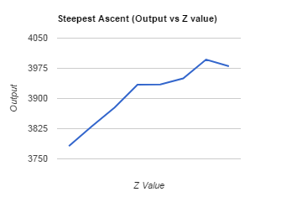

**Figure 1: First Steepest Ascent (Output vs. Z Value)**

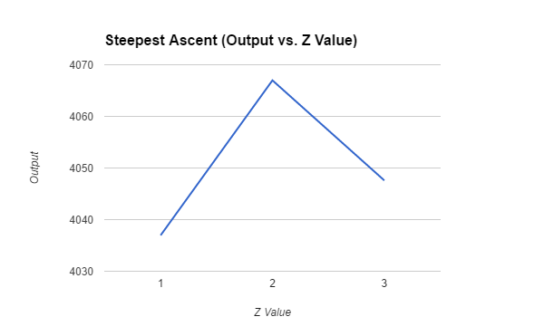

**Figure 2: Second Steepest Ascent (Output vs. Z Value)**

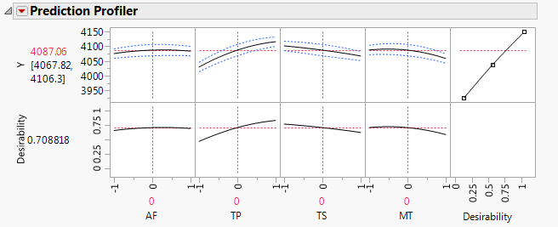

**Figure 3: Parabolas Following First Central Composite Design Process**

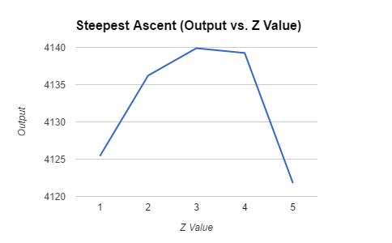

**Figure 4: Third Steepest Ascent (Output vs. Z Value)**

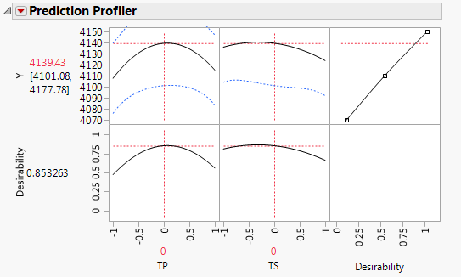

**Figure 5: Parabolas Following Second Central Composite Design Process**

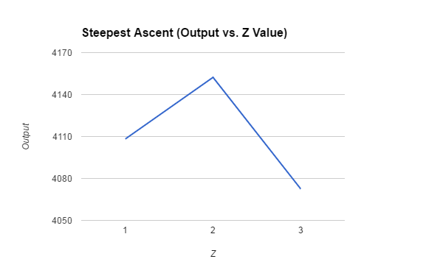

**Figure 6: Fourth Steepest Ascent (Output vs. Z Value)**

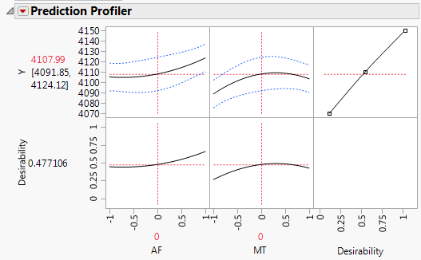

**Figure 7: Third Central Composite Design Process**

**Table 2: Rounds, Maximum Output, and Percent Improvement Data**

|  |  |  |  |  |  |  |
| --- | --- | --- | --- | --- | --- | --- |
| **Round** | **Runs** | **Purpose** | **Previous Maximum** | **Maximum** | **Percent Improvement** | **Total Percent Improvement** |
| 1 | 1-36 | Initial Screening | -- | 3714.52 | -- | -- |
| 2 | 37-44 | Steepest Ascent | 3714.52 | 3996.78 | 7.60% | 7.60% |
| 3 | 45-63 | New Model Refinement | 3996.78 | 4047.06 | 1.26% | 8.95% |
| 4 | 64-66 | Steepest Ascent | 4047.06 | 4066.98 | 0.49% | 9.49% |
| 5 | 67-73 | New Model Refinement | 4066.98 | 4096.33 | 0.72% | 10.28% |
| 6 | 74-99 | Central Composite Design | 4096.33 | 4135.2 | 0.95% | 11.33% |
| 7 | 100-105 | Steepest Ascent | 4135.2 | 4139.89 | 0.11% | 11.45% |
| 8 | 106-114 | Central Composite Design | 4139.89 | 4147.67 | 0.19% | 11.66% |
| 9 | 115-117 | Steepest Ascent | 4147.67 | 4152.3 | 0.11% | 11.79% |
| 10 | 118-127 | Central Composite Design | 4152.3 | 4141.6 | -0.26% | 11.50% |

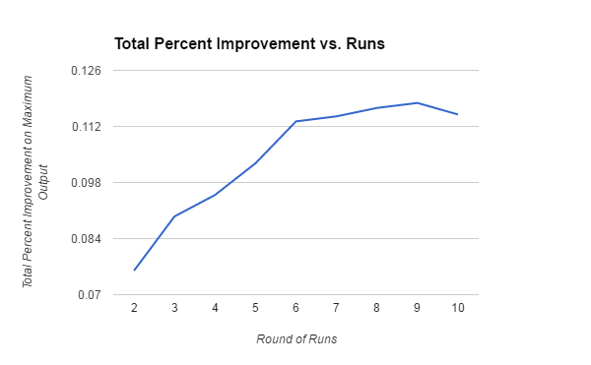

**Figure 8: Total Improvement Per Round of Runs**

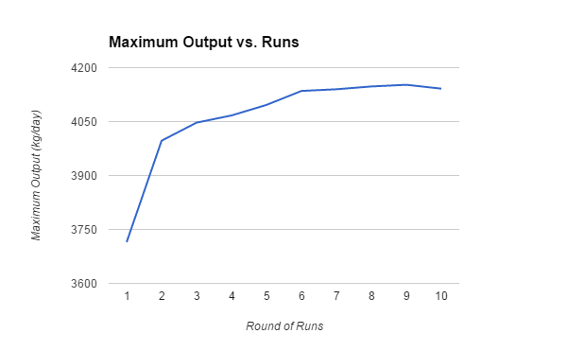

**Figure 9: Maximum Output vs. Round of Runs**